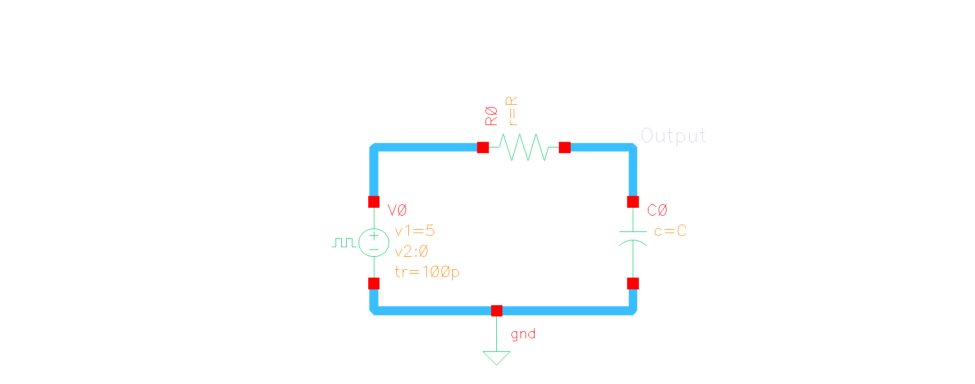**IEEE Analog IC Workshop**

**Part 1:**

**RC Fiter**

Figure 1 Circuit Designed

**Transient Analysis**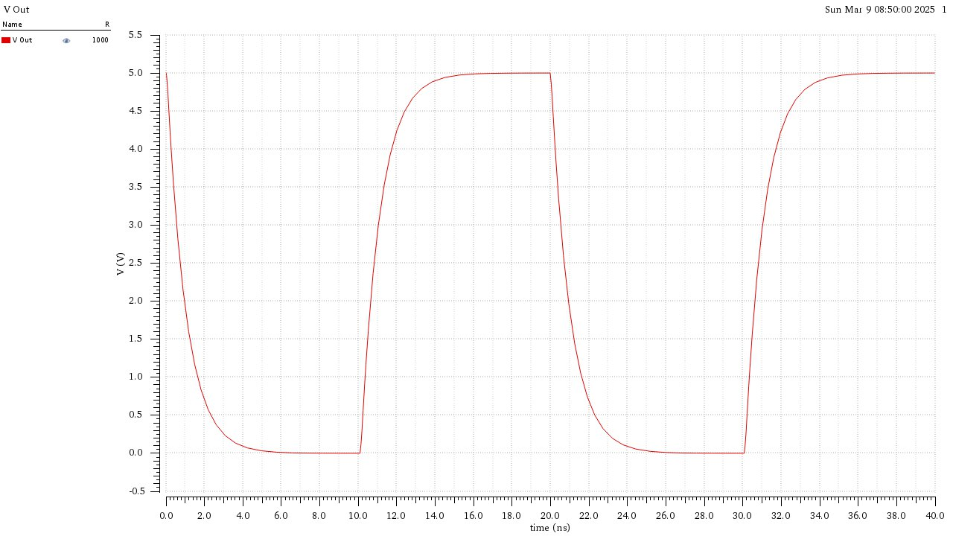

|  |  |  |  |
| --- | --- | --- | --- |
| **Test** | **Output** | **Nominal** | **Analytical** |
| **IEEE_Analog:Lab1_RC:1** | Falltime | 2.20E-09 | 2.19722E-09 |
| **IEEE_Analog:Lab1_RC:1** | risetime | 2.19E-09 | 2.19722E-09 |

**Parametric Sweep (R = 1:1:5kΩ):**

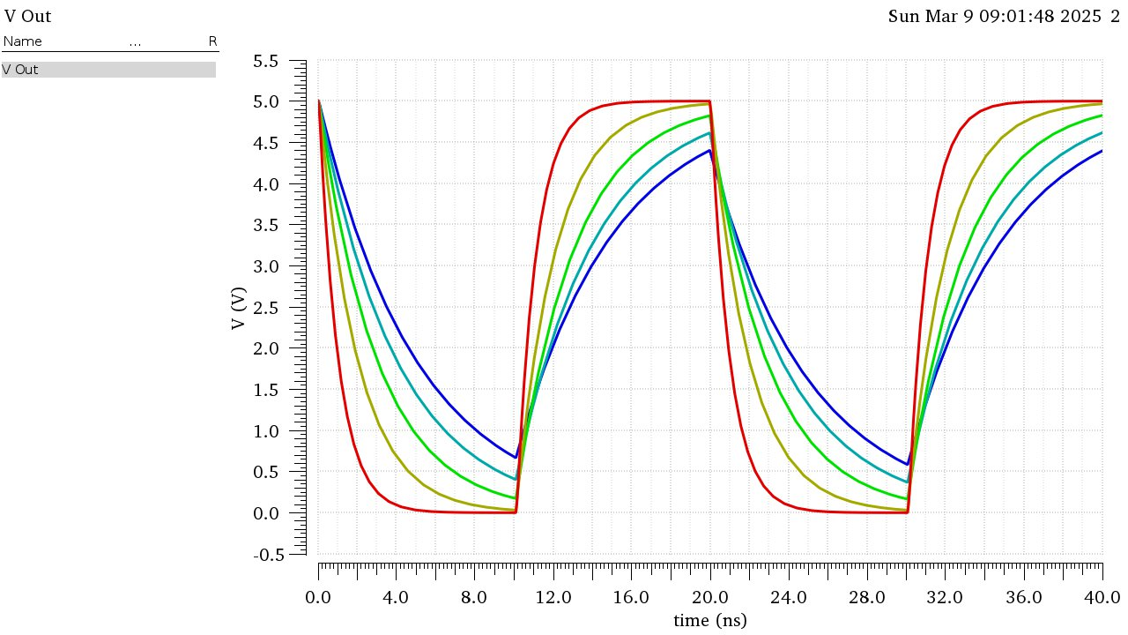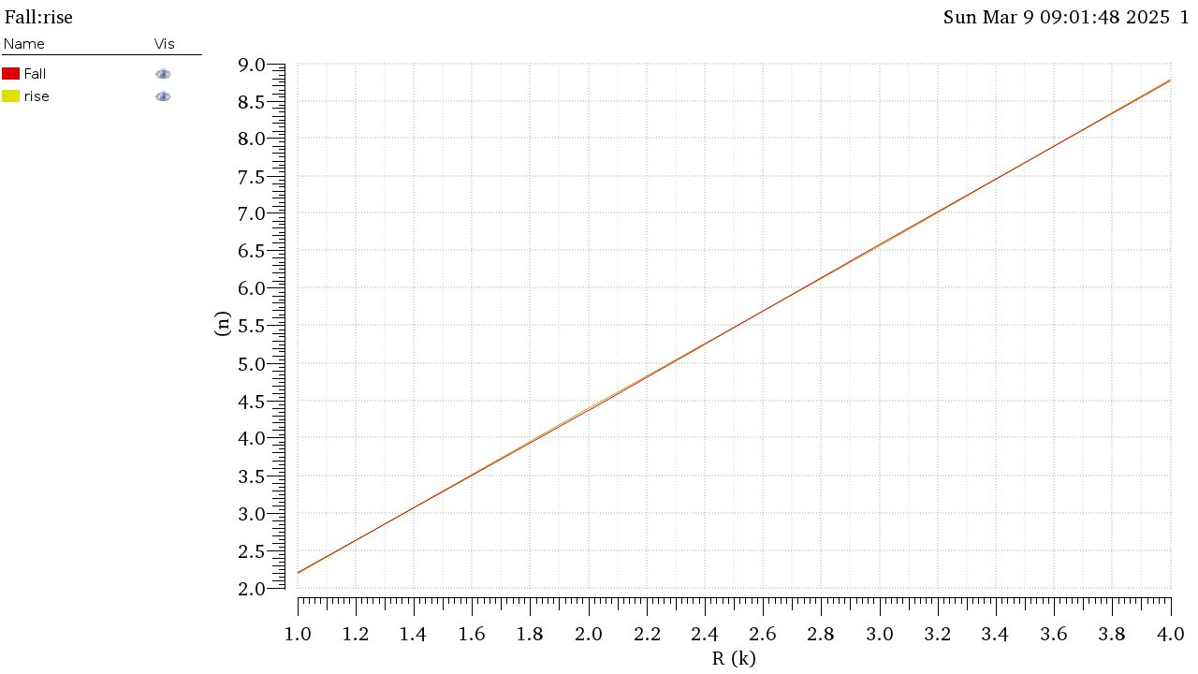

Increasing the R increases the time constant thus increasing the rise and fall time, making the square wave less pronounced as R increases.

**AC Analysis:**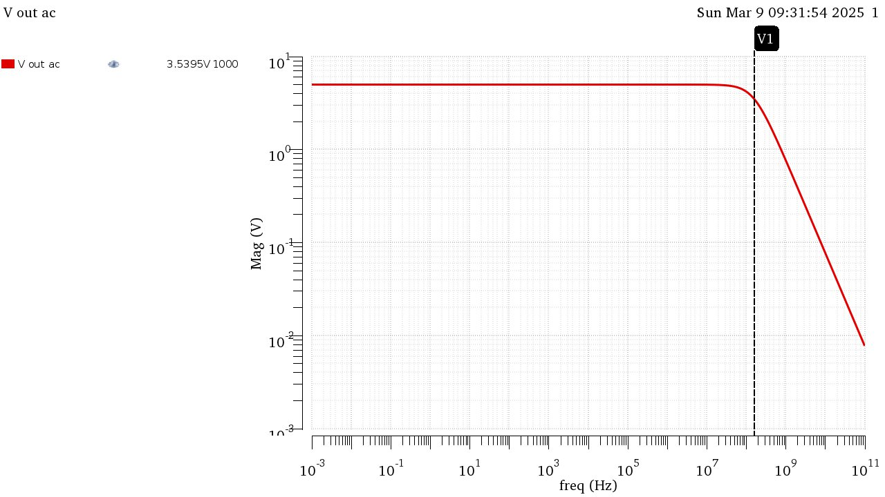

Figure 2 Bode Plot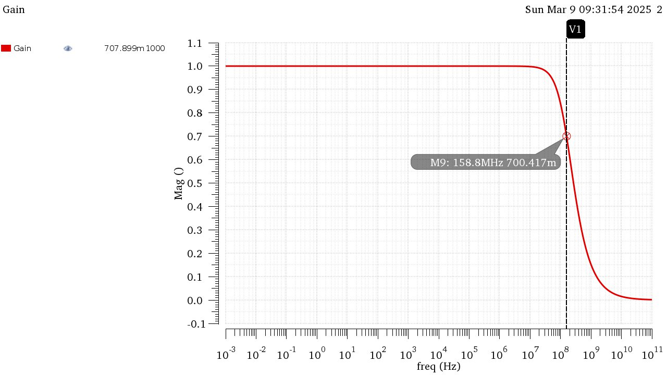

Figure 3 Gain

|  |  |  |  |
| --- | --- | --- | --- |
| **Test** | **Output** | **Nominal** | **Analytical** |
| **IEEE_Analog:Lab1_RC:1** | Bandwidth | 1.5880E+08 | 1.5915E+08 |

**Parametric Sweep 𝑅 = 1,10,100,1000𝑘Ω:**

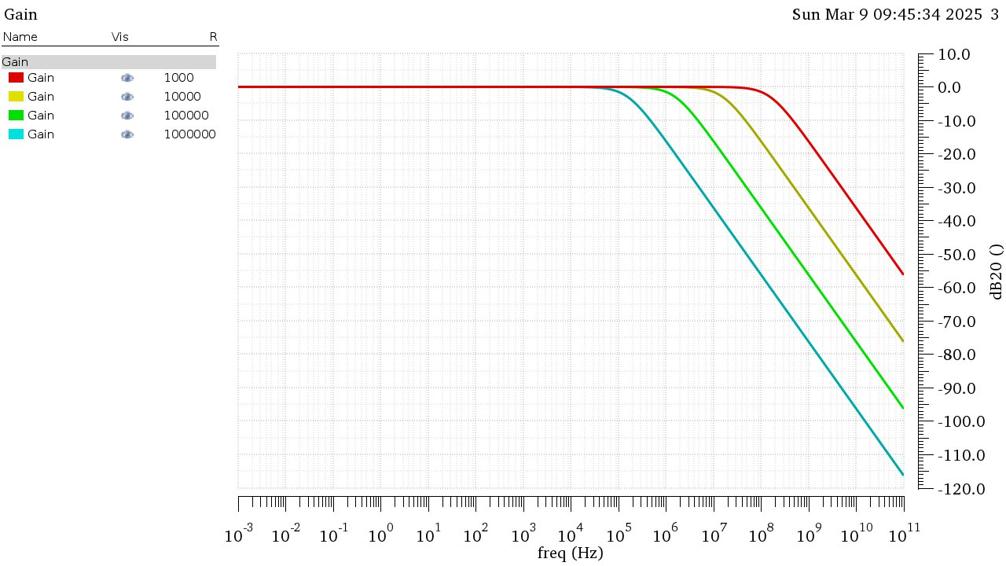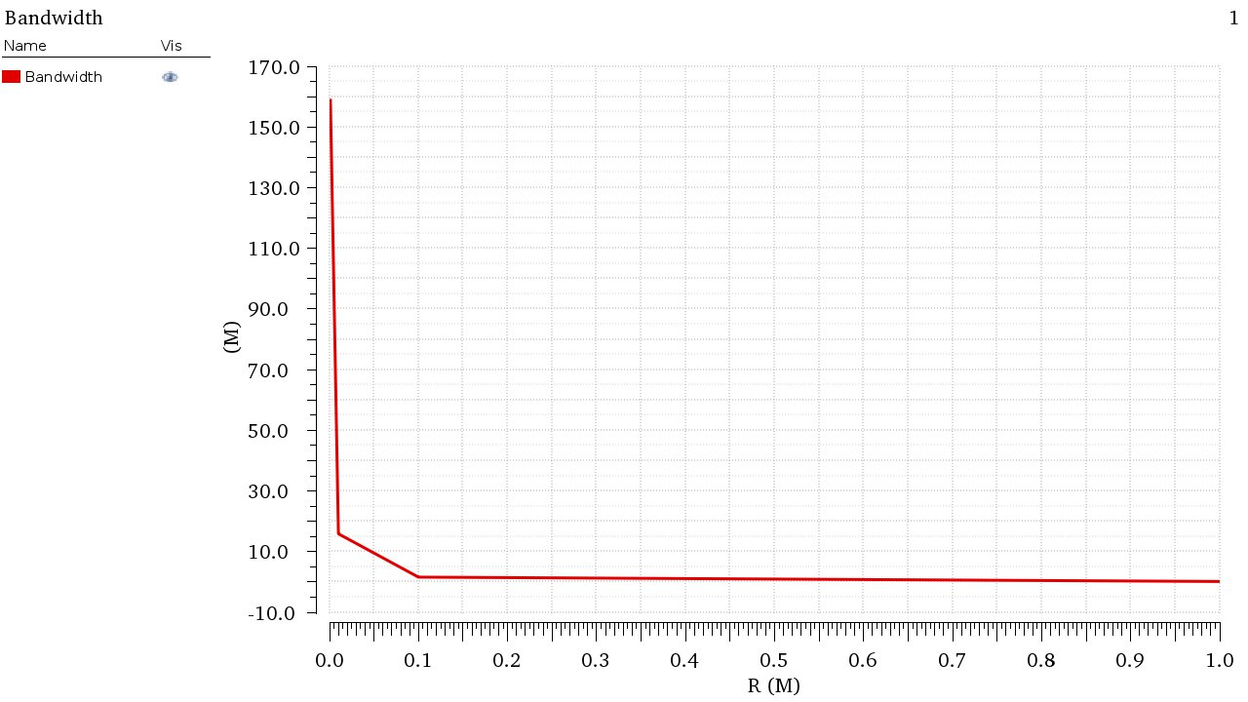

Increasing the resistance gradually increases the time constant thus increasing lowering the 3dB cutoff frequency and decreasing the bandwidth as seen from the graphs.

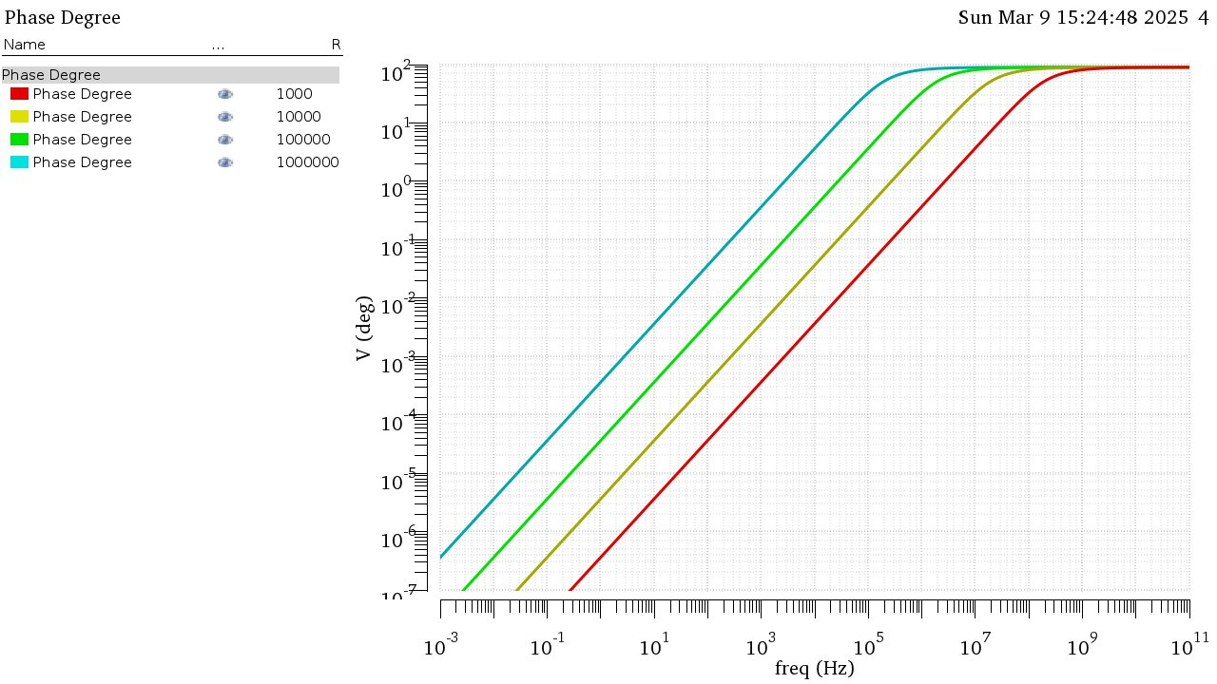

Figure 4 Phase graph

**MOSFET Characteristics**

**IDS vs VGS:**

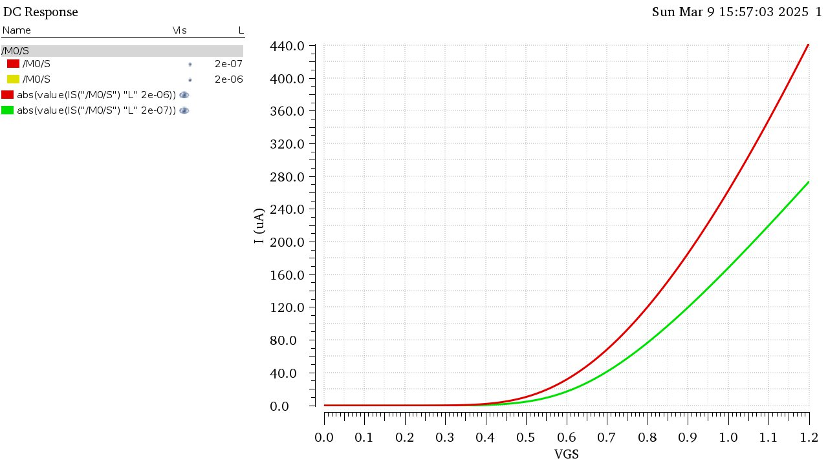

Figure 5 IDS vs VGS nmos

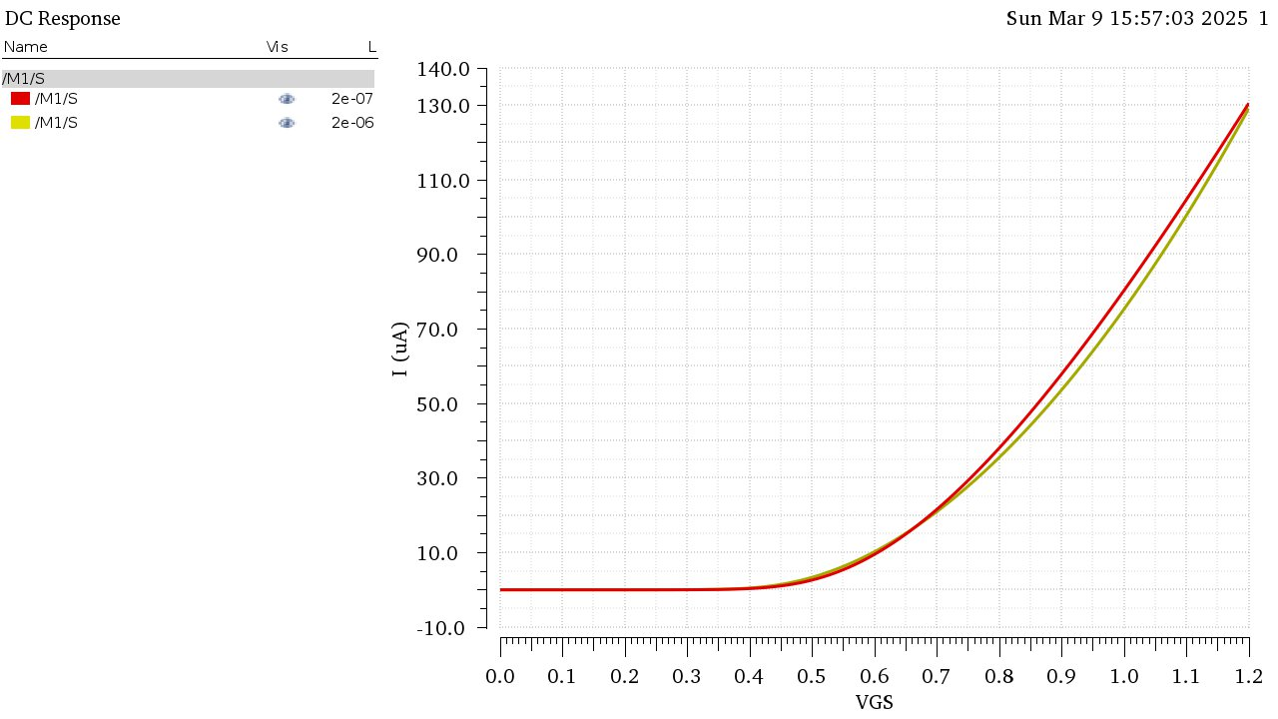

Figure 6 IDS vs VGS pmos

Long channel has higher current than short channel due to the lower electric field in the channel allowing the carriers to move more freely, the relation seems to be quadratic

NMOS has higher current than PMOS due to higher mobility of nchannel, the ratio between the currents at vgs = vdd is approximately 3.39 in long channel.

NMOS is most affected by short channel effect, due to the same reason.

Figure 7 gm vs VGS nmos

Figure 8 gm vs VGS pmos

gm seems to increase more linearly in long channel than short channel, this is to the constant increase of VGS in the triode region till it starts to saturate eventually as the mos enters the saturation region.

**ID vs VDS:**

Short channel results

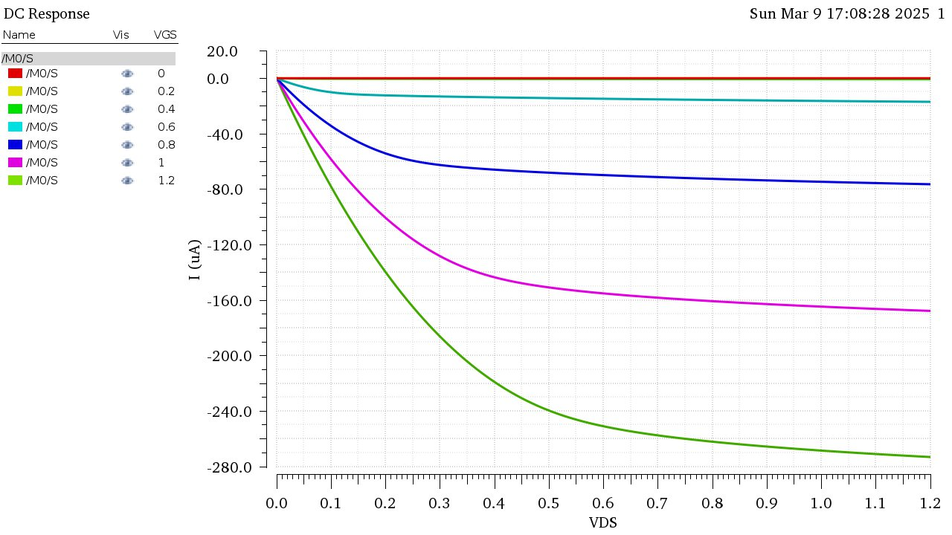

Figure 9 nmos

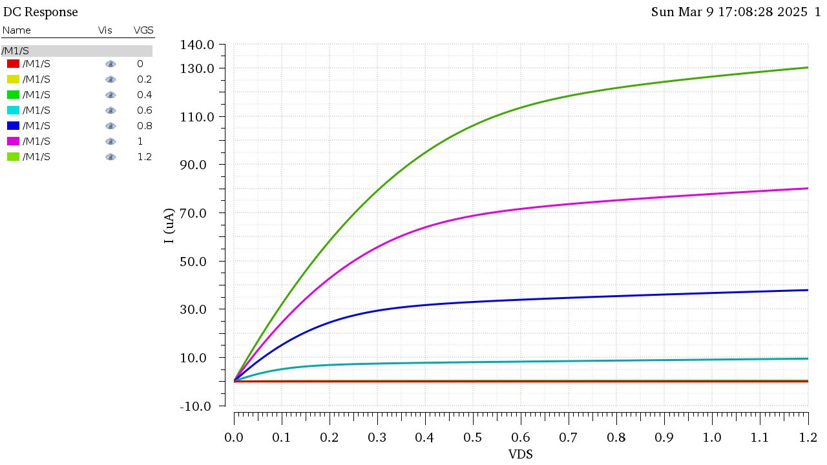

Figure 10 PMOS

Long Channel Results

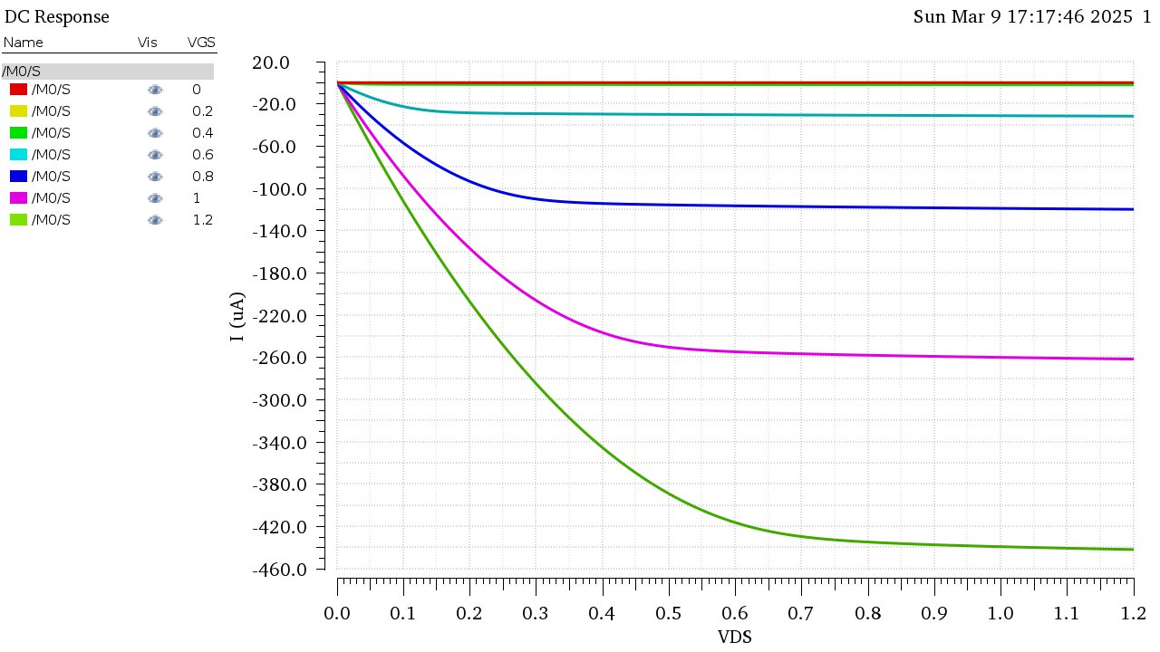

Figure 11 nmos

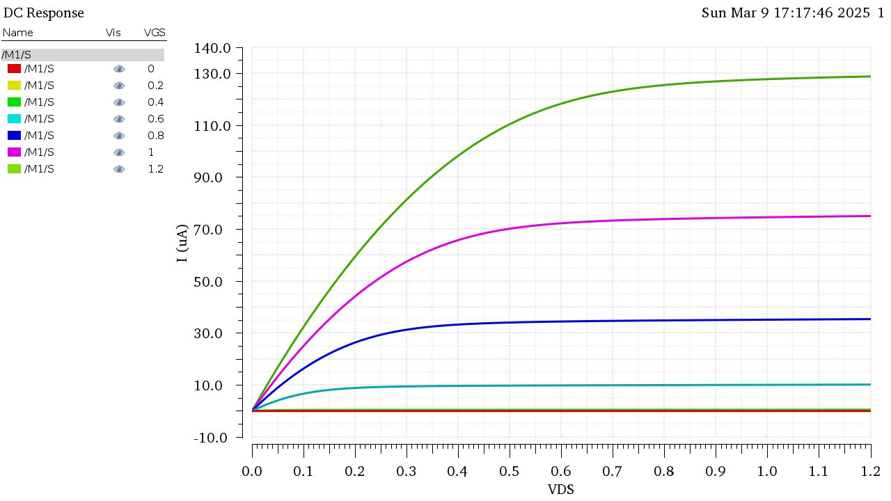

Figure 12 pmos

NMOS has significantly higher current than PMOS due to higher mobility of carriers.

Long channel has lower slope in saturation region due to the reduction of the effect of channel width modulation.